ANALYSIS OF MORPHOLOGICAL RESULTS OF KIDNEYS OF OFFSPRING OBTAINED UNDER CONDITIONS OF EXPERIMENTAL DIABETES

Mamadaliyeva Odinabonu
Master’s student, Department of Morphology, Tashkent State Medical University, Tashkent, Uzbekistan.
monaoydina@gmail.com
Tilyabov Ikrom
PhD, senior teacher Department of Human Anatomy and Clinical anatomy
Tashkent medical academy
Tashkent, Uzbekistan
tilyabovikrom@mail.com
0009-0005-1365-9474

Abstract In the world, among endocrine diseases, diabetes mellitus and its consequences, kidney pathologies occupy the highest place in prevalence. According to the World Health Organization (WHO), "... studies in Australia, Europe, Central Asia, the Middle East and North America show that the prevalence of kidney diseases among the population is 10-45%, with an average level of 26% ..." [WHO data 2022, https://www.who.org]. At the same time, the development of modern diagnostic capabilities in the diagnosis of the disease in order to avoid a negative impact on people's lives, the occurrence of various conditions leading to an increase in the disease, leads to morphological and functional changes in the subtractive system.
Key words: morphology, morphometry, kidney, glomerulus, hyperglycemic nephropathies, atrophy, sclerosis, streptocasin diabetes mellitus.
INTRODUCTION
The streptozotocin (STZ) model of diabetes is commonly used to study diabetic nephropathy, but the histological damage to the kidneys is mild and does not resemble or differ from that seen in diabetic patients. In a rat model of type 2 diabetes, overt renal histological abnormalities spontaneously develop [49; p. 67, 58].To date, most studies investigating the pathogenesis of diabetic nephropathy have used the STZ model. This model describes a number of pathological features such as mesangial cell activation and podocyte injury, advanced glycation end products with protein kinase C activation, and even after long-term morphological observation, the state of glomerular injury did not lead to profound changes, which emphasizes the need for additional models [25; p. 16-20, 68; 76-p, 73; 249-290-p].
The purpose assessment of morphological changes in the cortical part of the kidneys in offspring born from female rats with streptozotocin diabetes.
Subjects of the study: outbred, previously never given birth female rats weighing 160-180 g in the amount of 40, and 180 rat pups born from them (control group - 80, experimental group - 100), the cortical part of the kidneys of rat pups for morphological and morphometric studies.
RESULTS AND DISCUSSIONA.
Morphological changes in the nephron system and the cortex of the kidney offspring obtained in mice with streptozotocin diabetes (day 60)
The increase in the duration and development of the process under experimental conditions is manifested in the following morphological changes.
In particular, angiopathy that developed in the vessels around the renal glomerulus and proximal tubules in diabetes mellitus is manifested by a long course of the dystrophic process and a functional decrease in parenchymatous epithelial cells, as shown in Figures 1 and 2. In our work, the metaplasia of these proximal duct epithelia from a prismatic appearance to a cuboidal and relatively flat appearance indicates clearly developed dystrophic changes. In the area of ​​​​the distal tubes, the formation of sparse fibrous connective tissue is determined.
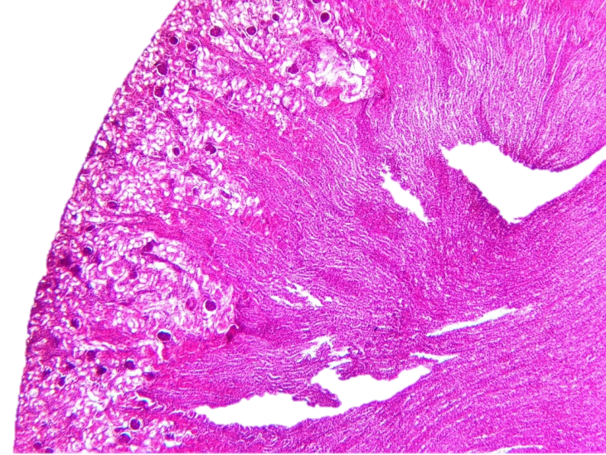
Figure 1. Results obtained on day 60 of the study. Reduced view of kidney tissue. Proximal cortical tubules are stained light pink. Most of the spheres are wrinkled and deformed. Hematoxylin and eosin stained image, 40x10.
As a result of the proliferative activity of the endothelium of the “rete mirabile” of glomeruli, angiosclerosis and a sharp decrease in podocytes, as a result of an increase in the proliferative activity of mesangial cells in Bowman’s space, the appearance of mesangioproliferative sparse fibrous structures in the form of a cap was observed.
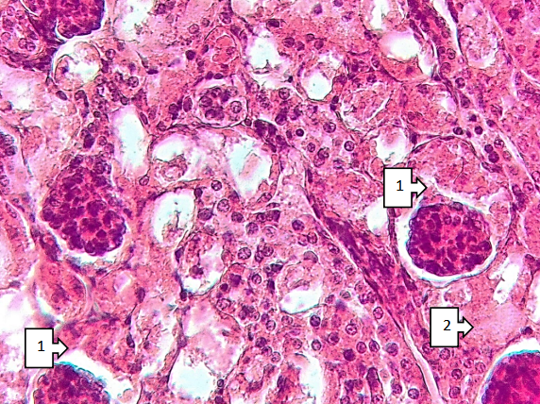
Figure 2. Results obtained on the 60th day of the study. Glomerulosclerosis in the form of a semi-solid fibrin cap in the Bowman's cavity of the cortical glomeruli (1), segmental necrosis of the proximal tubules around the sclerotic glomeruli (2), reticular protein structures are found in the distal tubules. Hematoxylin and eosin stained image, size 40x10.
These changes are shown in Figures 2-3. As a result of the proliferation of mesangial cells in the "rete mirabile", the displacement of capillaries to the periphery can lead to the development of glomerular deformation, and this process, in turn, can lead to a sharp decrease in the primary production of urine. Clinically, the development of diabetic glomerulosclerosis in the last final stages of diabetes mellitus leads to the development of endogenous uremic intoxication of most parenchymatous organs and the development of fibrinous inflammatory processes of varying severity. The development of hyaline droplet dystrophy in the glomerular epithelium leads to the development of the process of coagulation necrosis. These changes are mainly due to the duration of the process. The development of hyaline droplet dystrophy in the cytoplasm of the epithelium of the proximal tubules leads to a sharp disruption of the histioarchitecture of the tubules and a sharp disruption of the primary reabsorption of urine proteins and is clinically manifested by the development of proteinuria.
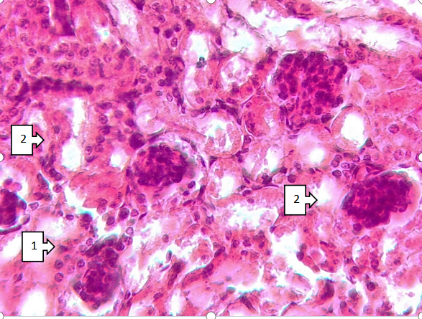
Figure 3. The results obtained on the 60th day of the study. Around the epithelia of most of the proximal canals, coarse fibrous connective tissue structures are identified (1), the balls are atrophically changed (2). Hematoxylin-eosin-stained image with a size of 40x10
In our work in Fig. 3, the presence of mesh-like homogeneous protein structures of pink color in the secondary urine in the space of proximal and distal tubules is considered as clear evidence of our opinion. This process, in turn, leads to a violation of the dynamics of secondary urine movement in the space of distal tubules and, if it continues together with a violation of mineral metabolism, then it continues with the formation of nephrolithiasis. As a result, on one side of the distal canals, as a result of blockage by mineral inclusions, enlarged foci of retention cysts are detected.In the nephron capsule, foci were found that developed in order of decreasing size. In turn, during dynamic morphological studies, thickening of the kidney capsule around deeply developed foci of the process, uneven filling in the tmuaries, and a change in the process to coarse fibrous structures around sparse fibrous structures were observed. In many foci in the epithelium of the proximal tubules, foci of segmental necrosis were found.These foci of necrosis are clearly developed in epithelial cells in the state of hyaline-drop dystrophy with deep dystrophic changes, as shown in Fig. 3. Thus, on the 60th day of our work, specific changes occurred in the kidneys, not obvious, but reparative regeneration of damaged tissue and activation of many adaptation mechanisms. In our work, foci of hypertrophy, hyperplasia and atrophic changes serve as a morphological substrate for adaptation processes. In our work, a sharp development of atrophic changes in the glomerular epithelium and the epithelium of the proximal canal is determined.
At the same time, an example of hyperplastic processes is the active proliferation of mesangial cells in the glomerular cavity and an increase in the proliferative activity of the vascular endothelium. On the 60th day, a less typical manifestation of pronounced sclerotic changes was observed in the kidneys and progressive renal fibrosis was observed. Renal fibrosis is a process characterized by the formation of sparsely formed fibrous structures around parenchymatous cells, which indicates even greater possibilities in the treatment of the disease. If the process is corrected (treatment with nephroprotectors), the process can be reversible. As a result, the capillary networks that have moved to the periphery return to recentralization, the resulting sparse fibrous structures are lysed under the action of elastase enzymes and the lost functional deficiencies are restored. In this case, nodular sclerotic foci in finely reticular structures moved to the periphery with complete closure of eye cells and, finally, glomerulosclerosis. Continues with the appearance and formation of foci of tubulointerstitial fibrosis around the tubules.
Conclusion: As a result, the appearance of reticular homogeneous protein structures is observed in the space of the distal tubules. However, in normal morphological forms, reticular homogeneous protein structures are not detected. As a result, cystic tubules are formed as a result of varying degrees of expansion of the spaces of the glomeruli and proximal-distal tubules. These changes are characteristic of type 2 diabetes mellitus, and the high sugar content in the primary filtration of urine leads to urodynamic disorders and a decrease in the reabsorption process. As a result, the appearance of increased carbohydrate and protein inclusions in the cytoplasm of the distal tubules leads to the development of focal coagulation necrosis of epithelial cells. As a result, clinically chronic renal failure develops.
REFERENCES
- Damasceno DC, Volpato GT, Sinzato YK, et al. Genotoxicity and fetal abnormality in streptozotocin-induced diabetic rats exposed to cigarette smoke prior to and during pregnancy. Experimental and Clinical Endocrinology and Diabetes. 2011;119(9):549–553.
- Delaney CA, Dunger A, Di Matteo M, Cunningham JM, Green MH, Green IC (1995) Comparison of inhibition of glucose-stimulated insulin secretion in rat islets of Langerhans by streptozotocin and methyl and ethyl nitrosoureas and methanesulphonates. Lack of correlation with nitric oxide-releasing or O⁶-alkylating ability. Biochem Pharmacol 50:2015–2020
- Damasceno DC, Kiss ACI, Sinzato YK, et al. Maternal-fetal outcome, lipid profile and oxidative stress of diabetic rats neonatally exposed to streptozotocin. Experimental and Clinical Endocrinology and Diabetes. 2011;119(7):408–413.
- Delaney CA, Dunger A, Di Matteo M, Cunningham JM, Green MH, Green IC (1995) Comparison of inhibition of glucose-stimulated insulin secretion in rat islets of Langerhans by streptozotocin and methyl and ethyl nitrosoureas and methanesulphonates. Lack of correlation with nitric oxide-releasing or O⁶-alkylating ability. Biochem Pharmacol 50:2015–2020
- Courtney M, Gjernes E, Druelle N, et al. The inactivation of Arx in pancreatic α-cells triggers their neogenesis and conversion into functional β-like cells. PLoS Genetics. 2013;9(10)e1003934
- Gross ML, Ritz E, Schoof A, et al. Renal damage in the SHR/N-cp type 2 diabetes model: comparison of an angiotensin-converting enzyme inhibitor and endothelin receptor blocker. Lab Invest 2003;83:1267–1277.
- Lenzen S (2007) Alloxan and streptozotocin diabetes. In: Peschke E (ed) Endokrinologie III Vorträge im Rahmen des Projektes ‘Zeitstrukturen endokriner Systeme’. [Endocrinology III lectures within the ‘time structures of endocrine systems’ project framework]. Abhandlung der Sächs. Akad. Wiss., Math-naturwiss Klasse, Verlag der Sächsischen Akademie der Wissenschaften, Leipzig, commissioned by S. Hirzel Verlag, Stuttgart/Leipzig, pp 119–138
- Rankin MM, Kushner JA. Adaptive beta-cell proliferation is severely restricted with advanced age. Diabetes. 2009;58:1365–1372.
- Thyssen S, Arany E, Hill DJ. Ontogeny of regeneration of beta-cells in the neonatal rat after treatment with streptozotocin. Endocrinology. 2006;147:2346–2356.
- Wilson GL, Hartig PC, Patton NJ, LeDoux SP (1988) Mechanisms of nitrosourea-induced beta-cell damage. Activation of poly(ADP-ribose) synthetase and cellular distribution. Diabetes 37:213–216

